DAY 8 – AZURE DATA FACTORY

Mapping Data Flow -

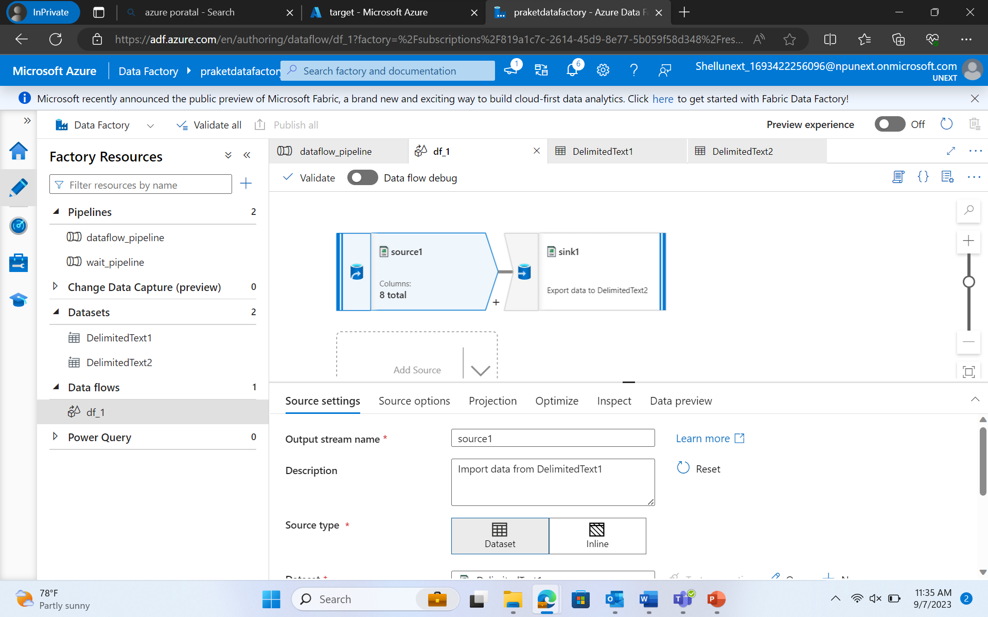

**Select Transformation -**

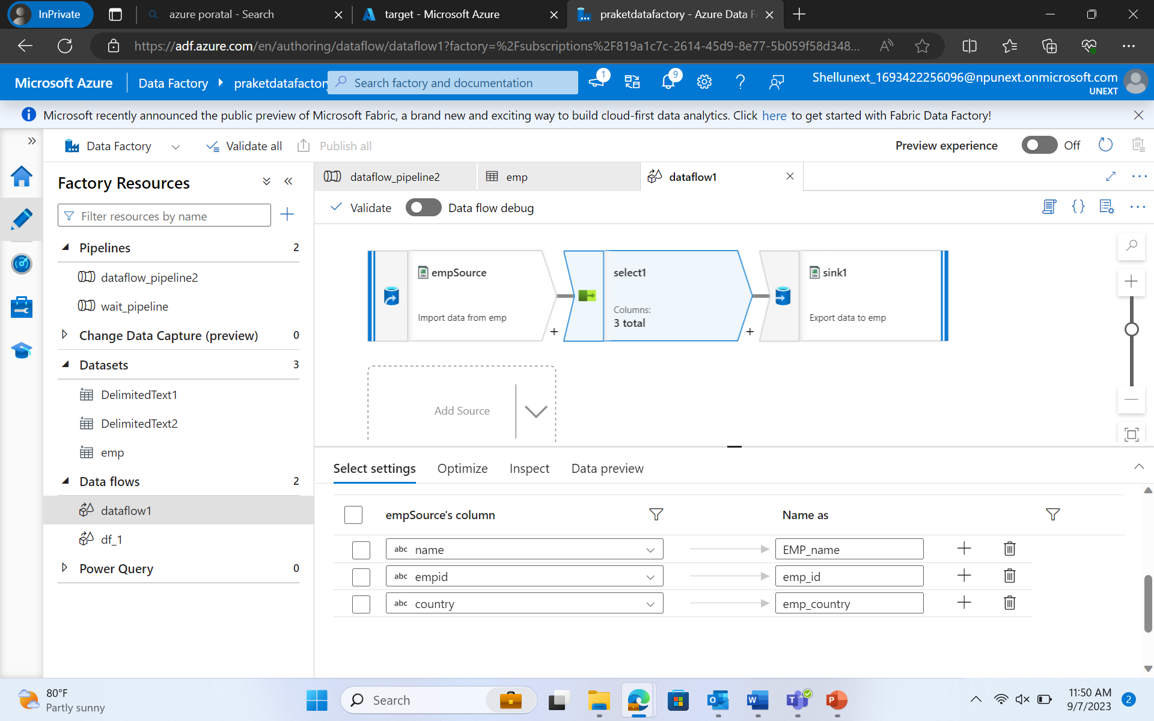

Conditional Split Transformation –

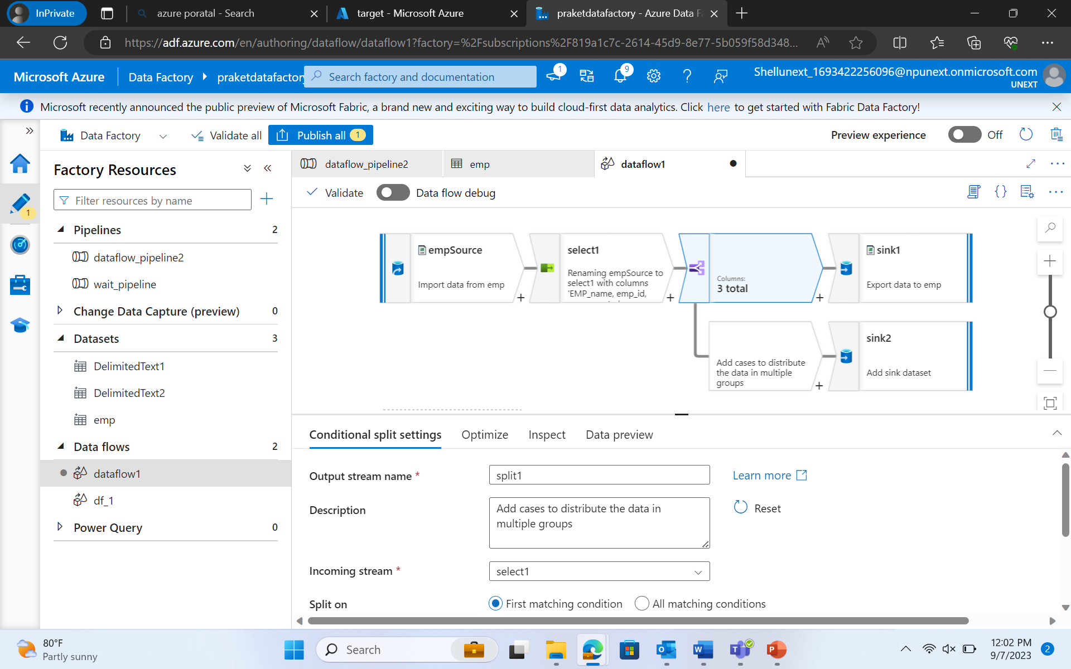

Derived Column Transformation -

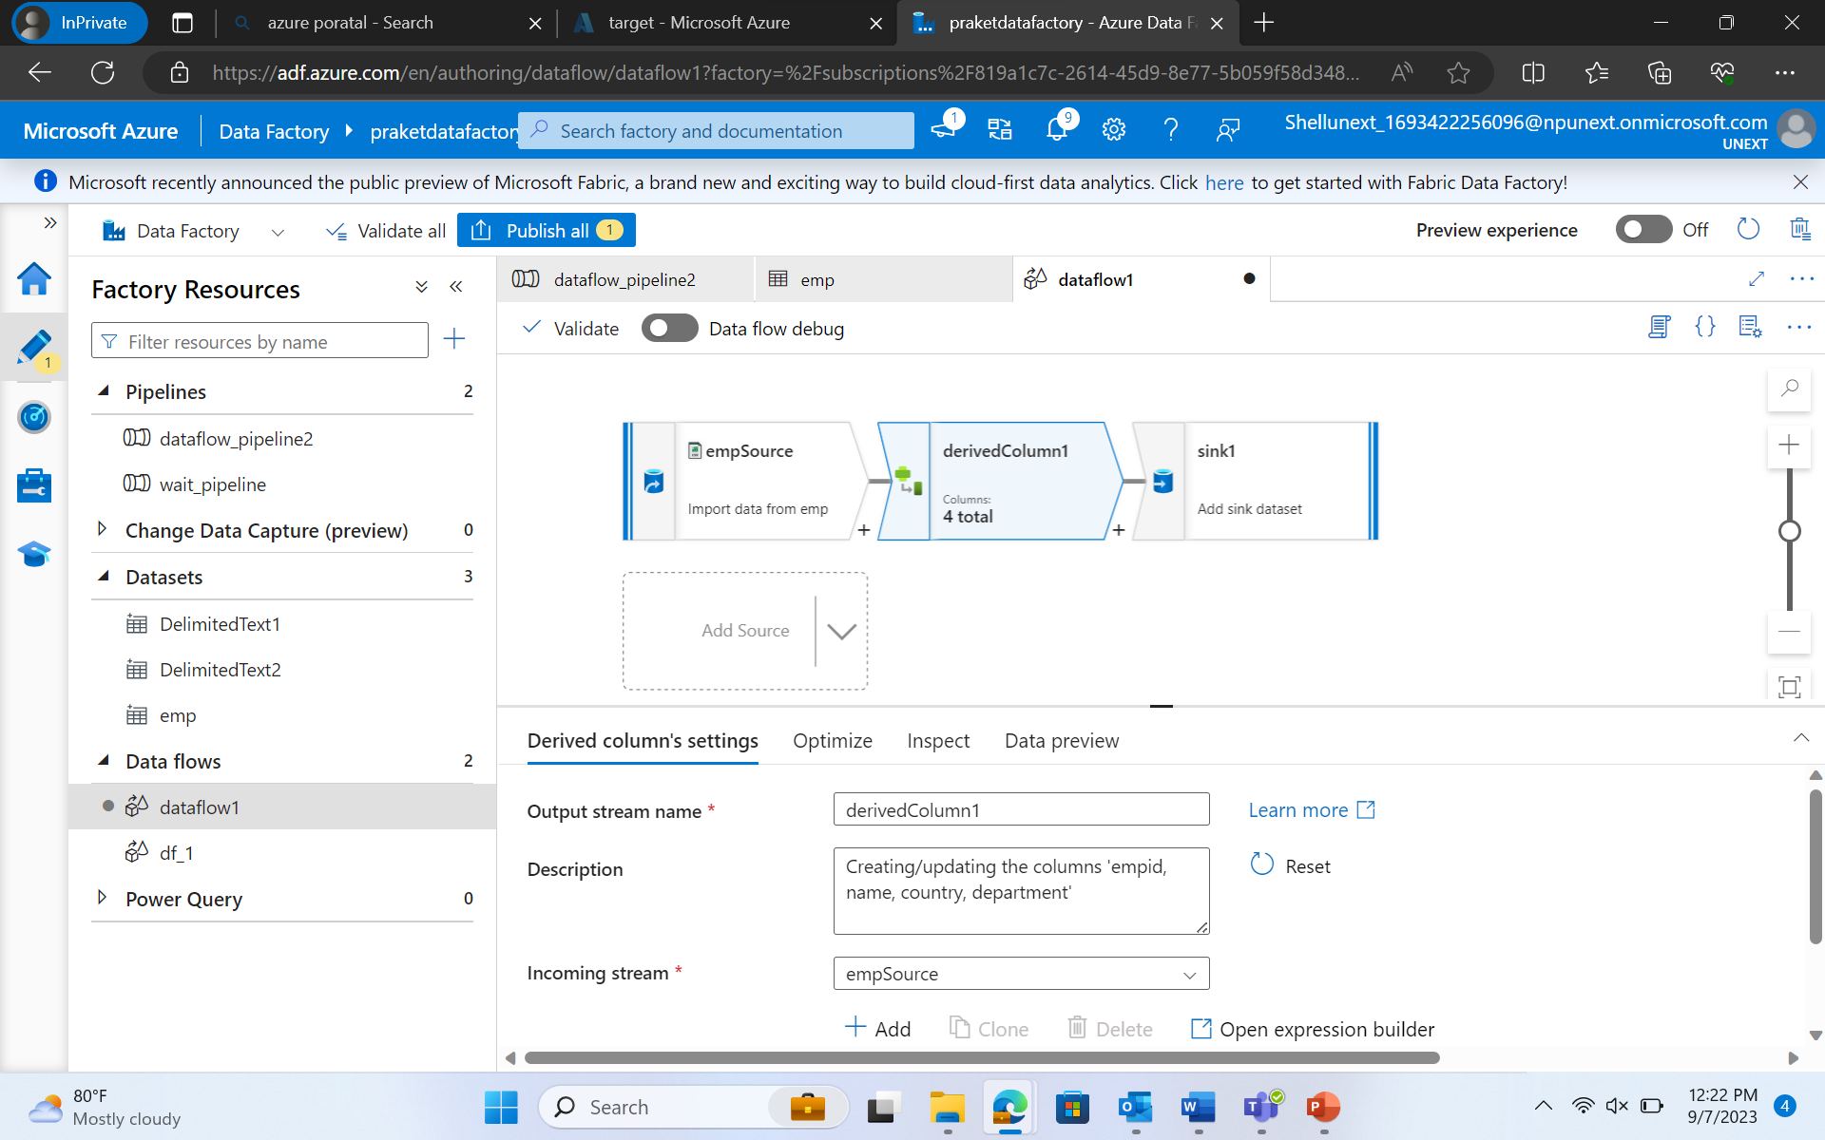

Union Transformation -

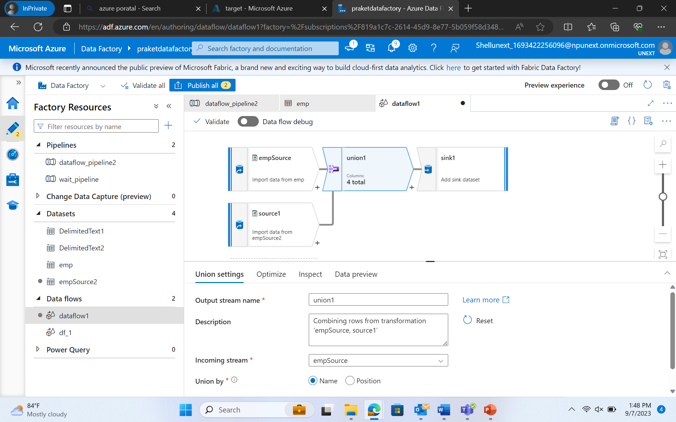

Sort Transformation –

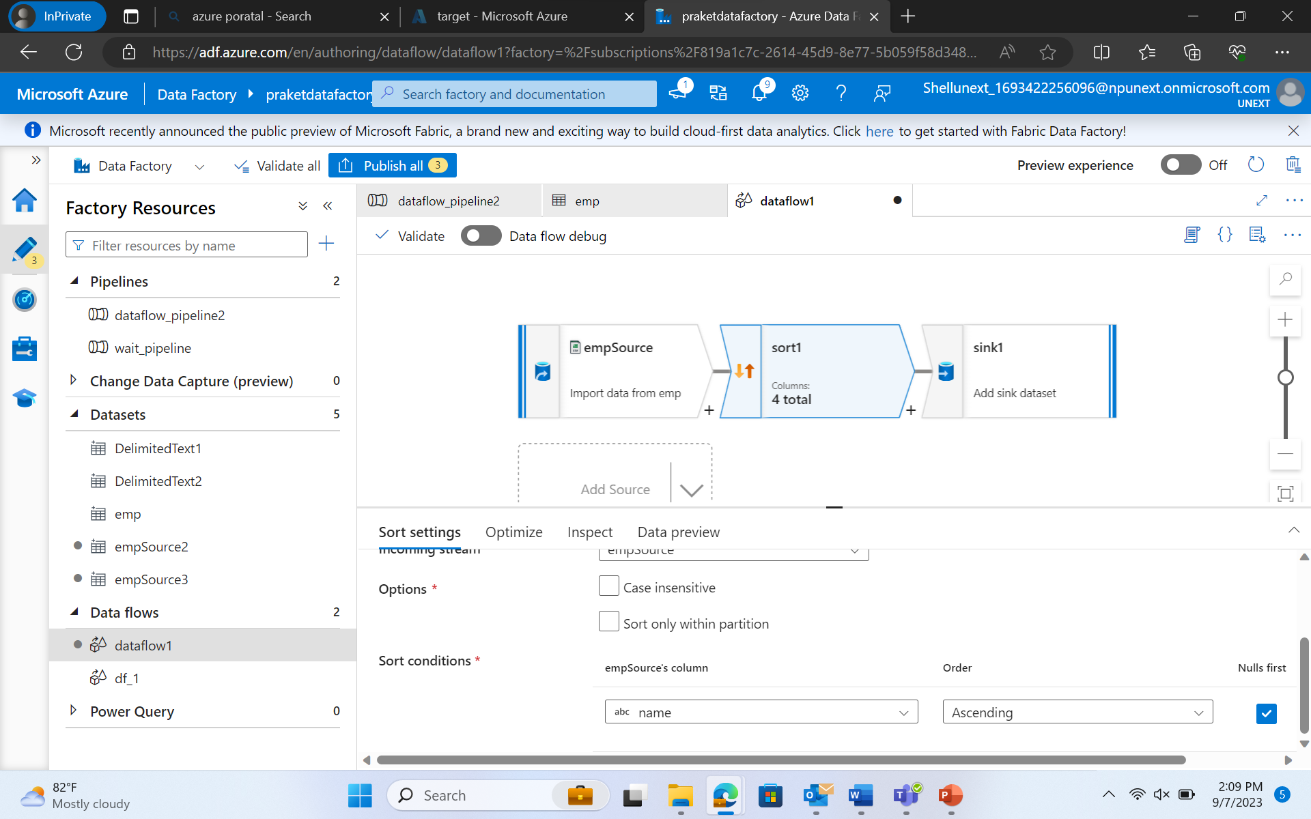

Surrogate Key Transformation –

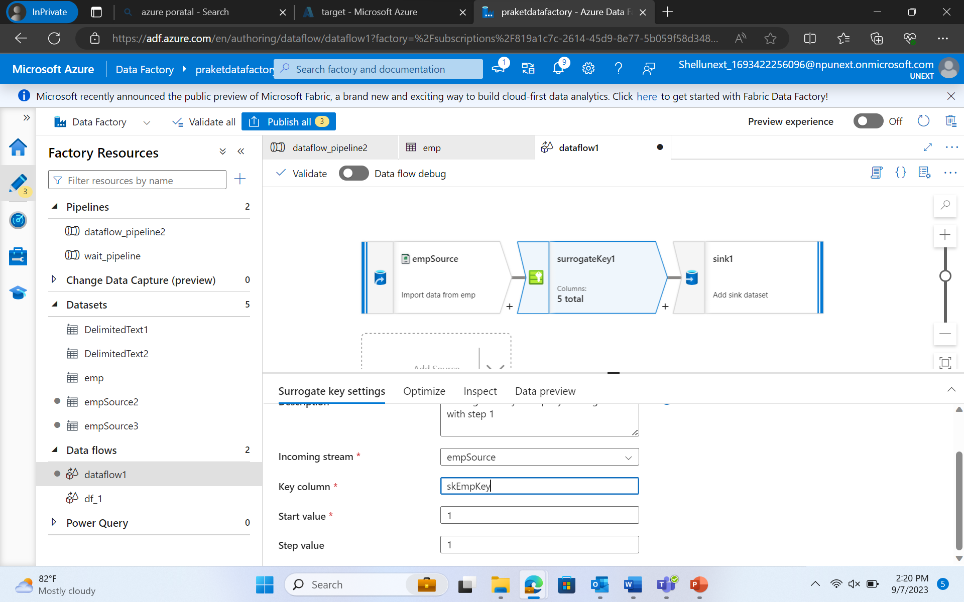

Filter Transformation –

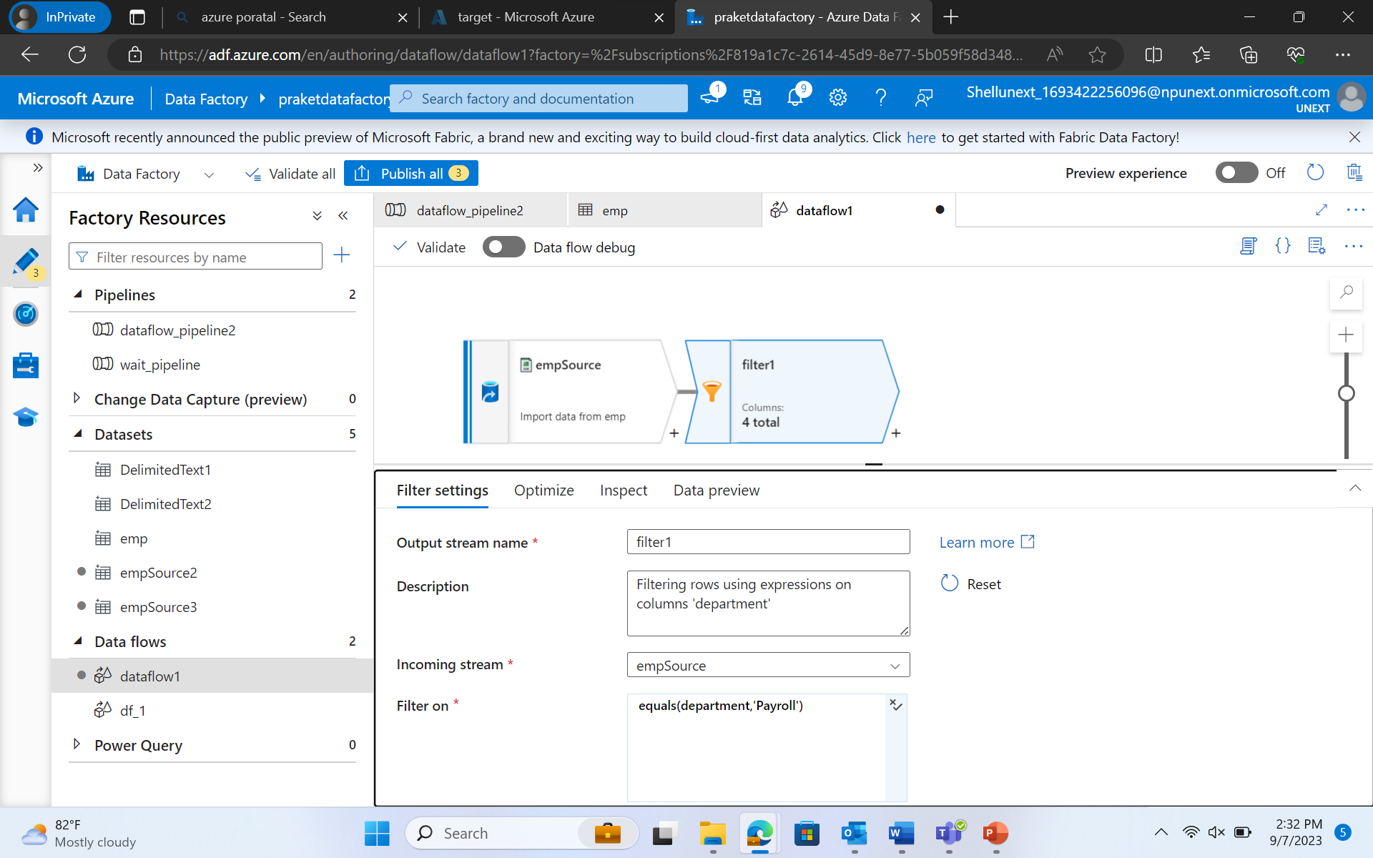

Aggregator Transformation –

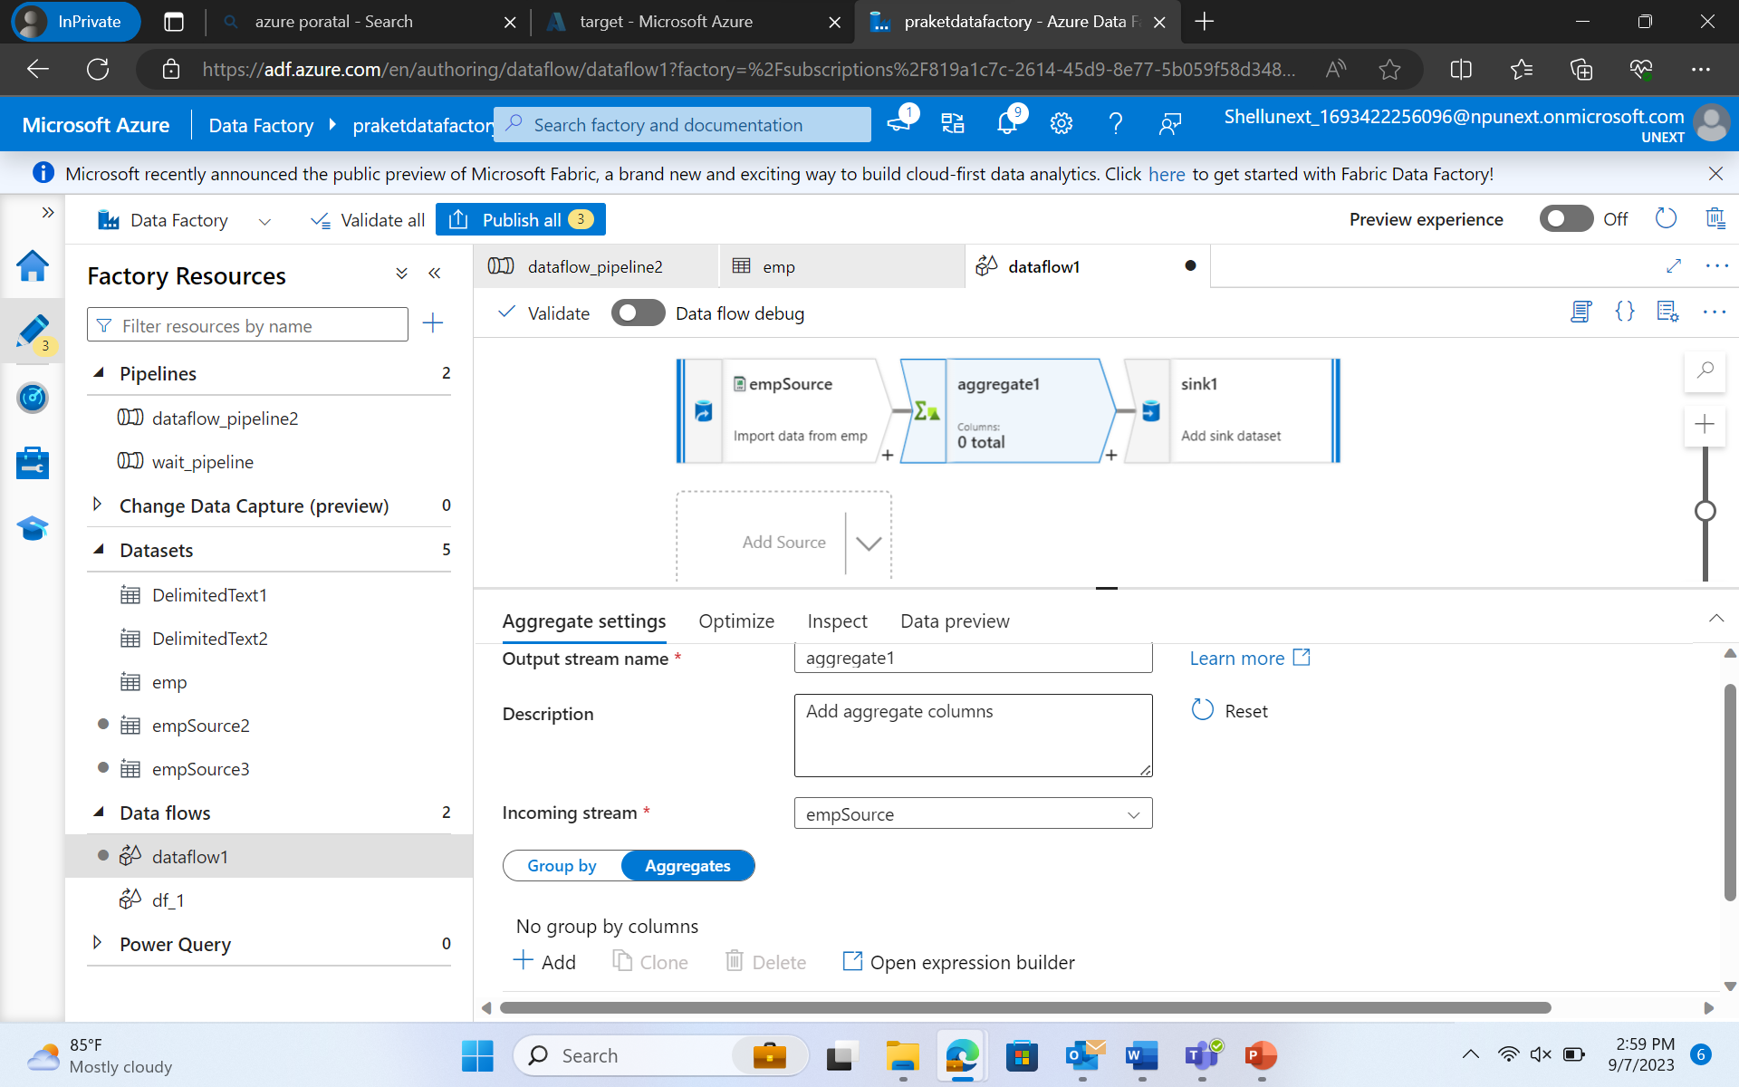

Join Transformation –

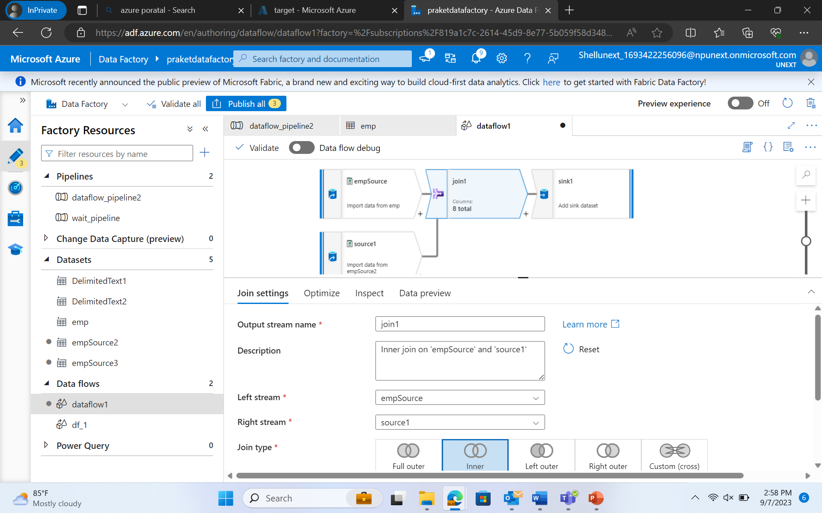

Lookup Transformation –

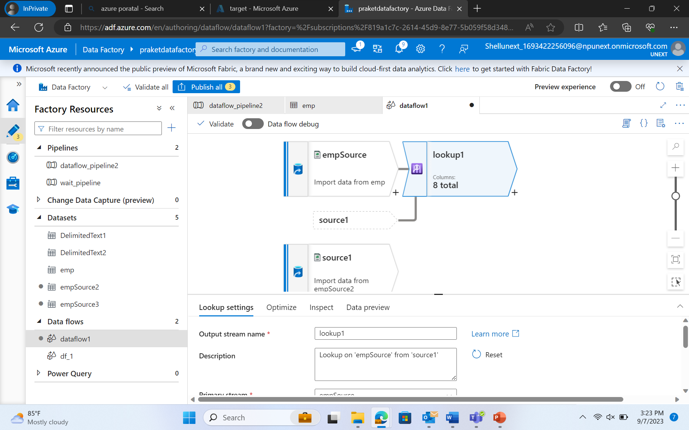

Pipeline Using REST –

Parameterize -

Stringify Transformation -

Pivot Transformation -

Unpivot Transformation -

Window Transformation -

Alter Row Transformation -

Cast Transformation -

Web Page Usage -

Rest Pagination -

Rank Transformation -

Parse Transformation -

Assert Transformation -